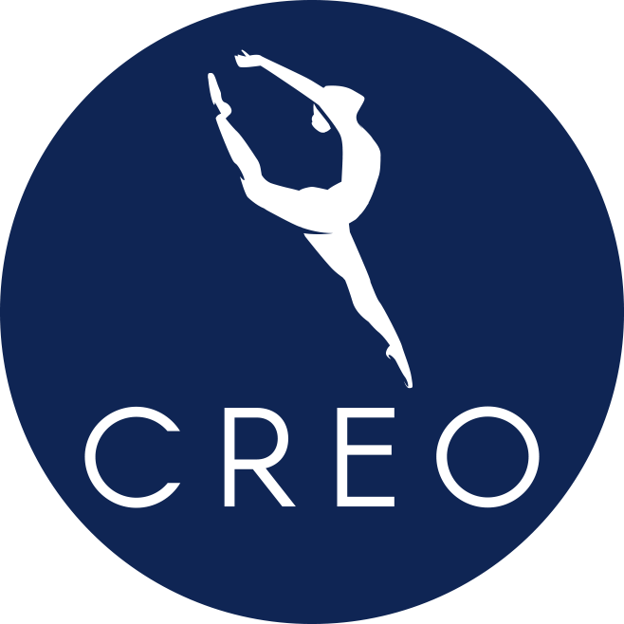

Grace and Peace to you, Dear CREO Families,
With faith and care, we have created a plan to bring movement back into our dance studio. We are thrilled to announce that we will open our doors for in-studio classes the week of June 15th. We will navigate these uncharted waters together, working as a team, to safely bring your child back to an in-studio activity of physicality, creativity, community, and faith. We are aware and completely understand that some families feel most comfortable online learning at this time. We will continue to offer all classes through our online platform.

Below, we introduce new guidelines for studio safety. These guidelines may change according to the guidelines of the CDC and State of Minnesota. Our intention is to safely, efficiently and mindfully open CREO doors with the health and wellbeing of all community members in mind.

HEALTH, CLASS SIZE & SOCIAL DISTANCING

Instructors will complete a health check list prior to entering the building each day. More than one instructor will be available to teach a class should an instructor need to go home.

IF YOUR CHILD OR A FAMILY MEMBER IN YOUR HOME has a fever, cough, or other COVID-like symptoms, please opt to stay home. We must all work together to provide a healthy and safe environment for our dancers.

All who enter the building will have their temperature taken.

Staff, dancers and parents may choose to wear masks but at this time are not required to wear one.

Class sizes will be limited according to the State of Minnesota guidelines.

- Studios 1, 2 and 3 have a limit of 10 dancers. (allows 8 ft. between dancers)
- Studio 4 has a limit of 8 dancers. (allows 8 ft. between dancers)
- Staff and dancers will be practicing social distancing at all times.

ENTERING & EXITING CREO

CREOis fortunate to have three entrances to the building. Dancers will receive information regarding which studio entrance door to use prior to their class week. A lobby attendant will be available for dancers as they enter and are in the building. The attendant’s responsibilities are to ensure dancers wash their hands properly, safely bring belongings to designated cubbies, wipe down doors and door handles, and assist anyone arriving late, and to generally make sure all safety plans are being followed.

DANCERS ENTERING GRADES 2-12

- A CREO representative will greet dancers grades 1-12 at their designated entrance.
- Dancers must wait until the previous class exits the building. Once the previous class exits, a new class may enter.
- Please do your best to be on time to class.
- Parents must drop their child off outside the building. At this time, parents that have children in this age group will not be allowed in the building. This is for the safety of the entire CREO community.
- Parents may watch their child’s class on CREO’S online platform.
- Over the summer, we will develop a parking lot drop off and pick-up system.
- One week prior to class, you will receive information on which designated entrance door to use.
- Encourage your dancer to visit your restroom before leaving your home.

DANCERS AGE 3-ENTERING GRADE 1

- In this age group, we understand that children need more assistance from a parent.
- We are piloting a new protocol for 3-4 year olds to facilitate social distancing guidelines. We would like to partner with you to teach your dancer how to joyfully and safely take class together. In the coming days we will publish this protocol on our website.
- ONE parent per dancer, may enter the building with their child. Parents are encouraged to return to their cars and view class on our online platform.
- At this time, no siblings over 12 mo. will be allowed into the building.
- One week prior to class, you will receive information on which designated entrance door to use.
- All tables have been removed from the lobby areas. Chairs must be kept 6 feet apart and social distancing is encouraged.
- Encourage your dancer to visit your restroom before leaving your home.

SANITIZING HANDS

Prior to entering the class, staff, dancers and parents are required to do one of the following:

- Use hand sanitizer. CREO will have hand sanitizer on hand but dancers are strongly encouraged to bring their own. We will always accept donations of hand sanitizer.
- Wash your hands at our new portable wash station.
- Wash hands in the bathroom. Bathroom entrance doors will stay propped open at all times to limit touch and the stall door locks will be disinfected before and after classes.

SANITIZATION OF CREO

- Tumbling mats and barres will be disinfected before and after each class. In some cases, they will also be sanitized during class.
- All cubbies, door handles, and high touch areas, will be sanitized between classes and at the end of each day.
- Staff will run a room check the last 5 minutes of class to ensure personal belongings are accounted for.
- Classes will end 5-7 minutes early so CREO staff can thoroughly disinfect all of the frequently touched surfaces in each studio.
- CREO will be regularly deep cleaned by a professional.
- Continental Property Group (landlord) will facilitate regular bathroom cleaning,

PERSONAL BELONGINGS

- All CREO dancers are required to bring a bag to class with essential items such as water bottle, dance shoes, etc. All bags will be kept in a designated cubby.
- Every dancer must have a Ziploc bag large enough to place street shoes in upon entering the building. After your dancer removes their street shoes, you will place them in the Ziploc bag and store them in your dance bag.
- Dancers will be REQUIRED to bring their own, prefilled water bottle to class. The water fountain will not be available for dancers at this time.
- For the health of your dancer and other dancers, NO food will be allowed into CREO at this time. We will keep you informed regarding how this will affect the Dance Blitz.
- Dancers must have their names on everything they bring into CREO. If something is left in the building that doesn’t have a name, it will be thrown away. If something is left in the building that has a name, we will place the item in a secure place. If your child believes they left something in the studio, they may ask a CREO staff member about it.
- Cell phones. Please encourage your dancer to keep expensive items safe in their bags.

During the summer you will likely see some addendums to these procedures. Let’s work together to ensure the physical and emotional well-being of your child is the highest standard of excellence.

Happy •Joyful •Ecstatic Dancing!!!
Ms. Christa

